e-design questionnaire

Name: Click or tap here to enter text
Email: Click or tap here to enter text
Address: Click or tap here to enter text
Phone Number: Click or tap here to enter text
Which Online Design Service(s) are you interested in? Check as many as apply.
DIY Design Package
E-Design Start to Finish Package
Idea Package
Floor Plan Design
Swatch Service
What design style(s) do you prefer? Check as many as apply.
Transitional
Modern/Contemporary
Bohemian
Traditional
Eclectic
Coastal
Modern Farmhouse
Industrial
Cottage
Other please describe here

What space needs interior design and what is the space used for?
Click or tap here to enter text

What is the approximate budget range for your project? Click or tap here to enter text

Describe your needs and wants for the design project here:
Click or tap here to enter text

Do you rent or own? Click or tap here to enter text

What is on your wish list for the room items needed? Check all that apply:
Furniture
Lighting
Rug(s)
Accessories

What current items need to stay in the room? (List items)
Click or tap here to enter text
How many people occupy the room at a given time?
Click or tap here to enter text

Does the room need to be kid or pet friendly? Are there any special considerations?
Click or tap here to enter text

Which of these color palettes are you drawn to the most for your space?
Check all that apply.

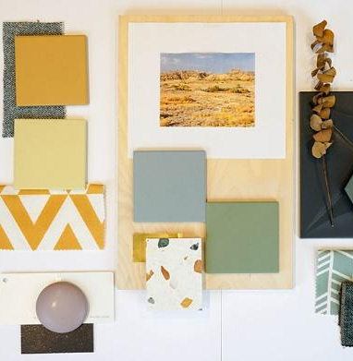
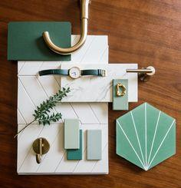

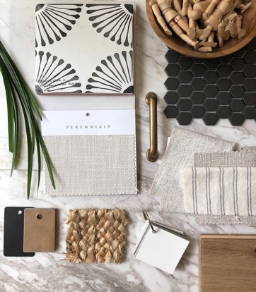
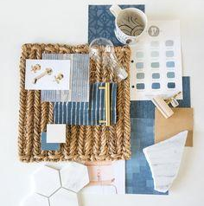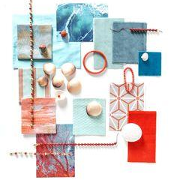

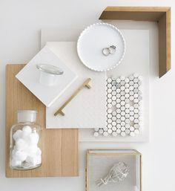
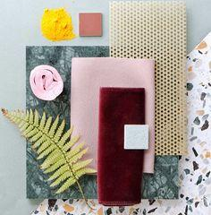
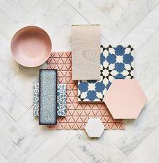

If you have a Pinterest board, Houzz idea board or other reference please provide links here: Click or tap here to enter text
What interior designers or home décor social media accounts do you like?
Click or tap here to enter text

Which of these color descriptions are you drawn to the most for your space?
neutrals
soft blues
medium to navy blues
yellow/mustard
terra cotta
orange
lavender/purples
soft greens
emerald to forest green
bright pops of color
What metal finishes do you prefer for this project? Check all that apply.
iron
brass
polished silver
brushed silver
bronze
other: Click or tap here to enter text

What are the overall measurements of the room? (windows, doors, walls & ceiling height) Click or tap here to enter text
Need help with this? We can walk you through it starting with the photos you send us!

Images to attach in this email:
- Room Sketch
- Overall Room Photo
- Wall 1
- Wall 2
- Wall 3
- Wall 4
Is there any additional info you can share about your vision for your space or your lifestyle?
Click or tap here to enter text
Whew! You did it!
Just email this to contact@thetatestudio.com! We will set up a time to review this with you, then get started on the design package you select!

We look forward to working with you and helping you to design your space!

Thetatestudio.com

